Information Gathering On RFID Reader/tag

==>In our project we need RFID module which can communicate with multiple
tag or cards.
==>For that RD522 RFID module is best which is multi-communication RFID
module for arduino or any other micro-controller.
==>Also known as MFRC-522 due to its NFX semiconductor. The module allows
developers to interface with any SPI, I2C and UART based microcontroler.
==>Its work on 13.56 MHz frequency. The RFID cards communicate with the
module at a short distance with radio frequency due to the mutual induction
technique.
==>The RFID cards and reader (RC522) can transfer data up to 10Mb/s.

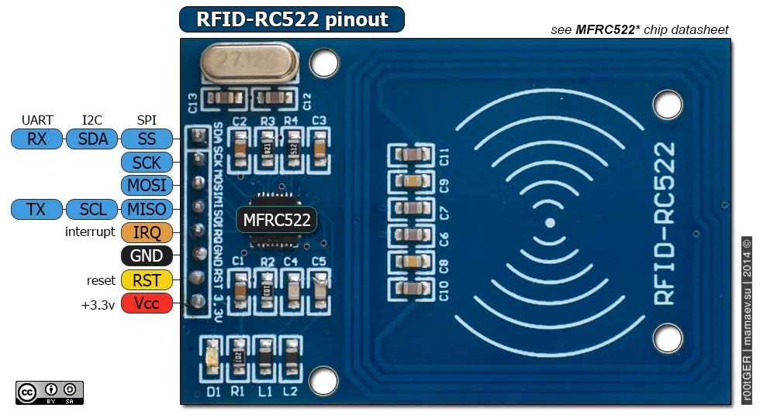

Power/Reset Pins
PINS |  | DETAILS
Pin 1 | VCC | The power pins are VCC. In some versions of RC522, this pin is denoted by 3V3 on the module instead of VCC.
Pin 2 | RST | It’s a reset pin for the module. Therefore, it uses to reset the device in case of an error on when a device isn’t giving any response.
Pin 3 | Ground | Ground helps to make the common ground with every external device, e.g. power Supply, Microcontroller or Arduino.

SPI and UART Communication Pins
PINS |  |  | DETAILS
Pin 4 | IRQ |  | The device can go into sleep mode to save power. So, the IRQ helps to wake it.
Pin 5 | MISO | SCL  TX | This pin connects with the Arduino/Microcontrollers for SPI communication. However, it transfers the data from module to Arduino.  The MISO pin is also useable for other functions instead of SPI.  It can also interface with I2C for clock pulse and UART Serial for Data transfer from the module.
Pin 6 | MOSI |  | MOSI is the data input pin for RFID module in SPI communication
Pin 7 | SCK |  | The SCK pins help to send the clock pulse in SPI communications.
Pin 8 | SS | SDA  RX | The SS pin is a chip enable pin in SPI communication. Therefore, it receives the signal when Master (Arduino) must perform SPI communication.  The SS pin in RFID is useable as a second pin (SDA) for I2C communication.  It also receives data during UART communication.

Required Library to program RFID and Important steps:

#include <SPI.h>
>>>>>>>>>establish the SPI communication

#include <MFRC522.h>
>>>>>>>>helps to decode and encode the incoming data from the RFID module

NOTE : These two libraries are dependent on each other

---------------------------------------------------------------------------------------------------

MFRC522 mfrc522(SS_PIN, RST_PIN);
>>>>>>>>>>describe the reset and slave select (SS) pin
>>>>>>>>>>above command change the SS_PIN with Slave select and RST_PIN
with reset pin of the RFID

---------------------------------------------------------------------------------------------------

SPI.begin();
mfrc522.PCD_Init();
>>>>>>>>>>describe the SPI initialization and Module initialization

----------------------------------------------------------------------------------------------------------------------------

mfrc522.PICC_IsNewCardPresent()
>>>>>>>>>>>Detect the card
mfrc522.PICC_ReadCardSerial()
>>>>>>>>>>read the data

NOTE : Sometimes the card can be present on the module but it has no data. Therefore, the second command ReadCardSerial will help to detect that
---------------------------------------------------------------------------------------------------
---------------------------------------------------------------------------------------------------

mfrc522.PICC_DumpDetailsToSerial(&(mfrc522.uid)); [decimal]
mfrc522.PICC_DumpToSerial(&(mfrc522.uid)); [HEX]
>>>>>>>>>>to see the dumb the data so it can decrypt

NOTE : the device can read and dump/decrypt the data of a single card at a time. Therefore, During Dumping the device won’t be able to read the new card.

---------------------------------------------------------------------------------------------------

MFRC522::StatusCode status //To read the status
mfrc522.PCD_Authenticate //To get the authentication
mfrc522.MIFARE_Read //To read the card
---------------------------------------------------------------------------------------------------
mfrc522.PICC_HaltA(); // Stop reading
mfrc522.PCD_StopCrypto1(); // Stop encryption on PCD
---------------------------------------------------------------------------------------------------

Write data into RFID tag

#include <SPI.h>
#include <MFRC522.h>S

constexpr uint8_t RST_PIN = D3; // Configurable, see typical pin layout above
constexpr uint8_t SS_PIN = D4; // Configurable, see typical pin layout above

MFRC522 mfrc522(SS_PIN, RST_PIN); // Instance of the class
MFRC522::MIFARE_Key key;

/* Set the block to which we want to write data */
/* Be aware of Sector Trailer Blocks */
int blockNum = 2;
/* Create an array of 16 Bytes and fill it with data */
/* This is the actual data which is going to be written into the card */
byte blockData [16] = {"Himanshu_Sharma"};

/* Create another array to read data from Block */
/* Legthn of buffer should be 2 Bytes more than the size of Block (16 Bytes) */
byte bufferLen = 18;
byte readBlockData[18];

MFRC522::StatusCode status;

void setup()
{
/* Initialize serial communications with the PC */
Serial.begin(9600);
/* Initialize SPI bus */
SPI.begin();
/* Initialize MFRC522 Module */
mfrc522.PCD_Init();
Serial.println("Scan a MIFARE 1K Tag to write data...");
}

void loop()
{
/* Prepare the ksy for authentication */
/* All keys are set to FFFFFFFFFFFFh at chip delivery from the factory */
for (byte i = 0; i < 6; i++)
{
key.keyByte[i] = 0xFF;
}
/* Look for new cards */
/* Reset the loop if no new card is present on RC522 Reader */
if ( ! mfrc522.PICC_IsNewCardPresent())
{
return;
}

/* Select one of the cards */
if ( ! mfrc522.PICC_ReadCardSerial())
{
return;
}
Serial.print("\n");
Serial.println("**Card Detected**");
/* Print UID of the Card */
Serial.print(F("Card UID:"));
for (byte i = 0; i < mfrc522.uid.size; i++)
{
Serial.print(mfrc522.uid.uidByte[i] < 0x10 ? " 0" : " ");
Serial.print(mfrc522.uid.uidByte[i], HEX);
}
Serial.print("\n");
/* Print type of card (for example, MIFARE 1K) */
Serial.print(F("PICC type: "));
MFRC522::PICC_Type piccType = mfrc522.PICC_GetType(mfrc522.uid.sak);
Serial.println(mfrc522.PICC_GetTypeName(piccType));

/* Call 'WriteDataToBlock' function, which will write data to the block */
Serial.print("\n");
Serial.println("Writing to Data Block...");
WriteDataToBlock(blockNum, blockData);

/* Read data from the same block */
Serial.print("\n");
Serial.println("Reading from Data Block...");
ReadDataFromBlock(blockNum, readBlockData);
/* If you want to print the full memory dump, uncomment the next line */
//mfrc522.PICC_DumpToSerial(&(mfrc522.uid));

/* Print the data read from block */
Serial.print("\n");
Serial.print("Data in Block:");
Serial.print(blockNum);
Serial.print(" --> ");
for (int j=0 ; j<16 ; j++)
{
Serial.write(readBlockData[j]);
}
Serial.print("\n");
}

void WriteDataToBlock(int blockNum, byte blockData[])
{
/* Authenticating the desired data block for write access using Key A */
status = mfrc522.PCD_Authenticate(MFRC522::PICC_CMD_MF_AUTH_KEY_A, blockNum, &key, &(mfrc522.uid));
if (status != MFRC522::STATUS_OK)
{
Serial.print("Authentication failed for Write: ");
Serial.println(mfrc522.GetStatusCodeName(status));
return;
}
else
{
Serial.println("Authentication success");
}

/* Write data to the block */
status = mfrc522.MIFARE_Write(blockNum, blockData, 16);
if (status != MFRC522::STATUS_OK)
{
Serial.print("Writing to Block failed: ");
Serial.println(mfrc522.GetStatusCodeName(status));
return;
}
else
{
Serial.println("Data was written into Block successfully");
}

}

void ReadDataFromBlock(int blockNum, byte readBlockData[])
{
/* Authenticating the desired data block for Read access using Key A */
status = mfrc522.PCD_Authenticate(MFRC522::PICC_CMD_MF_AUTH_KEY_A, blockNum, &key, &(mfrc522.uid));

if (status != MFRC522::STATUS_OK)
{
Serial.print("Authentication failed for Read: ");
Serial.println(mfrc522.GetStatusCodeName(status));
return;
}
else
{
Serial.println("Authentication success");
}

/* Reading data from the Block */
status = mfrc522.MIFARE_Read(blockNum, readBlockData, &bufferLen);
if (status != MFRC522::STATUS_OK)
{
Serial.print("Reading failed: ");
Serial.println(mfrc522.GetStatusCodeName(status));
return;
}
else
{
Serial.println("Block was read successfully");
}

}

Card Reading Code :

#include <SPI.h>
#include <MFRC522.h>
#include <Servo.h>

#define SS_PIN 10
#define RST_PIN 9

//#define SERVO_PIN 3
//Servo myservo;

#define ACCESS_DELAY 2000
#define DENIED_DELAY 1000
MFRC522 mfrc522(SS_PIN, RST_PIN); // Create MFRC522 instance.

void setup()
{
Serial.begin(9600); // Initiate a serial communication
SPI.begin(); // Initiate SPI bus
mfrc522.PCD_Init(); // Initiate MFRC522

//myservo.attach(SERVO_PIN);
//myservo.write( 70 );
//delay(7500);
//myservo.write( 0 );
Serial.println("Put your card to the reader...");
Serial.println();
}
void loop()
{
// Look for new cards
if ( ! mfrc522.PICC_IsNewCardPresent())
{
return;
}
// Select one of the cards
if ( ! mfrc522.PICC_ReadCardSerial())
{
return;
}
//Show UID on serial monitor
Serial.print("UID tag :");
String content= "";
byte letter;
for (byte i = 0; i < mfrc522.uid.size; i++)
{
Serial.print(mfrc522.uid.uidByte[i] < 0x10 ? " 0" : " ");
Serial.print(mfrc522.uid.uidByte[i], HEX);
content.concat(String(mfrc522.uid.uidByte[i] < 0x10 ? " 0" : " "));
content.concat(String(mfrc522.uid.uidByte[i], HEX));
}
Serial.println();
Serial.print("Message : ");
content.toUpperCase();
if (content.substring(1) == "69 C8 E2 2A") //change here the UID of the card
{
Serial.println("Authorized access");
Serial.println();
//myservo.write( 70 );
//delay(7500);
//myservo.write( 0 );
}
else {
Serial.println(" Access denied");
delay(DENIED_DELAY);
}
}

